**Design Document**

**kkc21, ll375, xz72**

**Introduction**

This document defines the interface, database and architecture design for Project Chataholic.

**Interface**

The interface should contain the main activity page, chat room, setting page and register/login page. As this project aims to design a cross-platform application, there are two interface design sections -- mobile and web. The following indicates the functions should be implemented to the pages respectively.

**Mobile**

For the main activity page:

* Pairing users when user request
* A friend list should be displayed on this page
* Add other user to / Delete user from the friend list
* Enter the chat page and the setting page
* Logout

For the chat page:

* Send, receive and delete messages
* Clear chat history
* Back to the main activity page
* Each message should be displayed with the time that it has been sent out
* Read other user profile but cannot edit it
* Modify notification setting
* Report user

For the setting page:

* Checks and edits the profile
* Check their account
* Change the account password
* Back to the main activity page
* Modify the notification settings (general)

For the login page:

* Login
* Create a new account
* Request to change password if the user has forgotten the old password

**Web**

For the main activity page:

* Pairing users when user request
* A friend list should be displayed on this page
* Add user to / Delete user from the friend list
* Logout
* Enter the setting page
* Read other user profile
* Chat room
  + Send, receive and delete messages
  + Each message should be displayed with the time that it has been sent out
  + Clear history
  + Modify notification setting
  + Display the user profile
  + Report user

For the setting page:

* Checks and edits the profile and account details
* Change password
* Logout
* Back to the main activity page

For the login page:

* Login
* Create a new account
* Request to change password if the user has forgotten the old password

**Database**

ER Diagram:

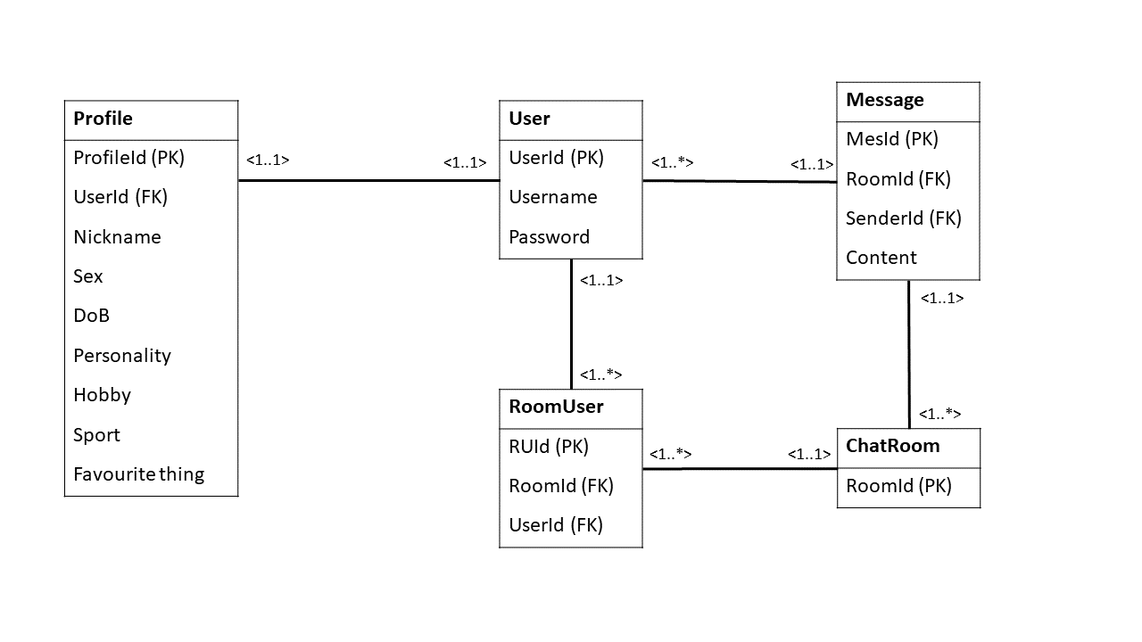

**Architecture**

The architecture consists of the mobile application, web application, a server and a database which communicate via an API.

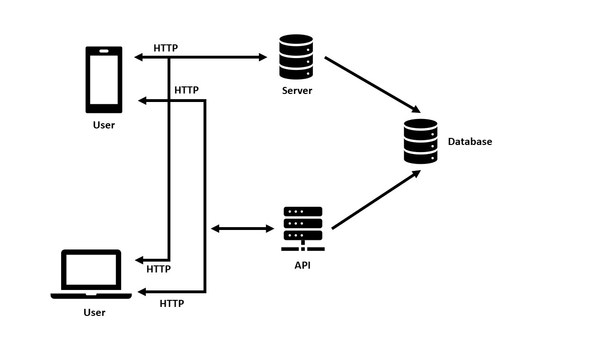

**API - Chat System**

The chat system should keep track of all connected users and the state of each chatroom

**Server-Side:**

**Chatroom**

* Holding a message history
* Holding a list of user for the chatroom
* Add User (socket) to the list
* Add new message which is sent by a user (push to the history)
* Broadcast the message to all the users in the room
* Delete a message from the history
* Clear the history

**RoomManager**

* Holding a list of chatroom
* Handling the event for the chatroom
* Create and add chatroom to list and DB
* Remove the chatroom from list and DB
* Get and return a chatroom from the list

**Handler**

* Handle disconnect from the socket -> Remove the chatroom from the list
* Handle initialise the data

**Client-Side:**

**Chatroom**

* get the chatHistory by passing the room id to server side
* Send new message
* Delete message